The Women’s Big Book Retreat 2020
is proudly sponsored by
Utah State Division of Substance Abuse and Mental Health

Driving Directions Camp Rodgers YMCA Camp

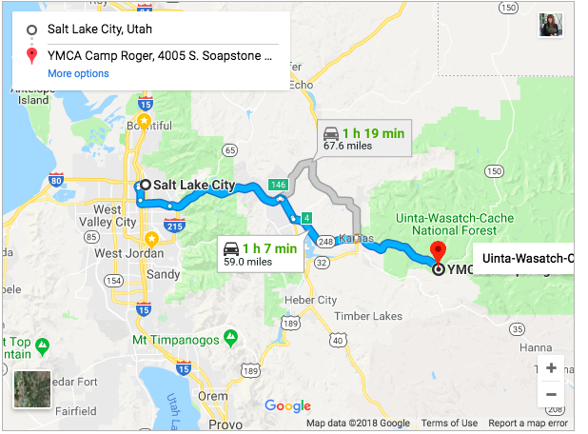
YMCA Camp Roger is located in the Soapstone Basin, 14.5 miles east of Kamas, UT on Highway 150 (Mirror Lake Highway).
Camp Address is: 4005 S SOAPSTONE BASIN RD
- From Salt Lake City, take I-80 east past Park City
- Exit 146 on to US 40 to Heber
- Go approximately 4-5 miles toward Heber on US 40
- Take Exit 4 to Park City ⁄ Kamas and turn left toward Kamas, 11 miles
- Once in Kamas, turn left at the first stoplight
- At the NEXT stoplight, turn right on to Highway 150 toward Mirror Lake
- Travel along Highway 150 for 14.5 miles until you reach Soapstone Basin
- Turn right, go across the bridge and keep following the dirt road until you see the sign for YMCA Camp Roger on your left.
- Follow the sign into camp
- Located in Soapstone Basin, 14.5 miles east of Kamas, UT on Highway 150 Mirror Lake Highway Transportation

Trust God in All Things he has great GPS God’s Protection System

